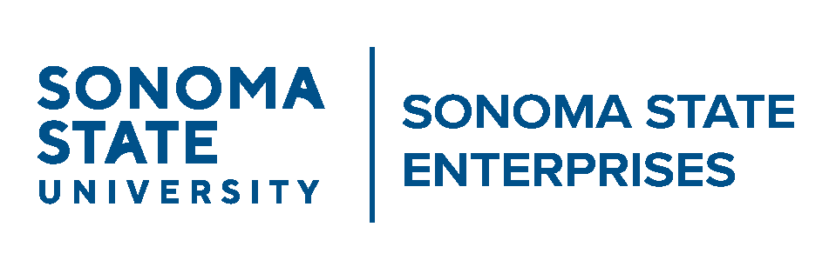

Audit Committee
Friday, May 11, 2026
1:00 p.m.-2:00 p.m.
Via ZOOM
https://SonomaState.zoom.us/j/88254369888?jst=2

AGENDA

- Call to Order
- Approval of the September 11, 2025 Minutes
- Audit Planning and Timeline
- CSU Auxiliary Audit Presentation
- Other Non-Action Items

